The Absinthe Thinker  Pablo Picasso | 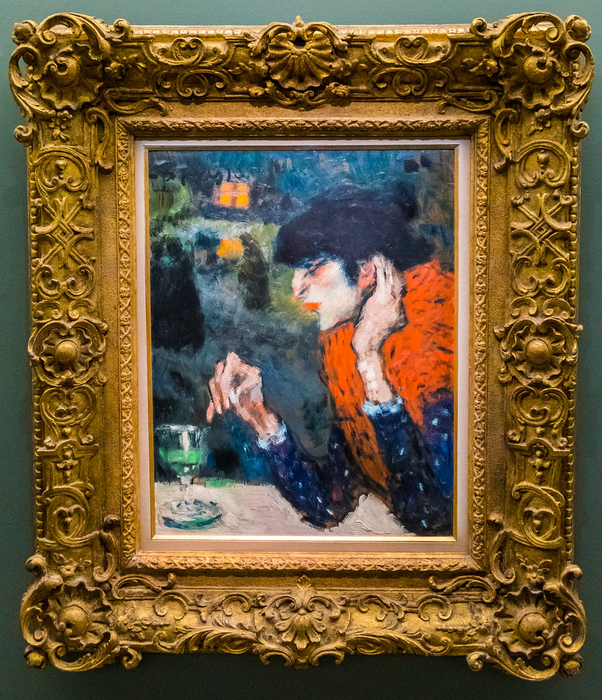
ㅡ  Why did you select it? | You can write here what made you analyze this particular image (topic, technique, theme, mood, genre, anything else?) What makes it stand out?  I saw this painting during my visit to a handful of museums in Paris and it caught my attention straight away after looking at the description stating that it is the work of Picasso. I have never thought about his work before the cubist movement so this was refreshing to see, showing his growth as an artist which was comforting to see.
ㅡ  Theme and Tone | What did it make you feel ? / What was the main emotion of this piece?  At first I thought it was a lonely women drinking by herself, but looking at it again I reinterpret it as someone who is mature and confident to be lonely. This comes from her clothes, the big red fur (which is surprisingly up to current fashion trends), her hands gently touching the back of her ears. I can almost see the action of her lifting her wine glass and taking a tiny sip play in my head in slow motion. Even the perspective of the painting makes me feel like I am observing someone who if I see I real life, I wouldn’t be able to keep my eyes off. She is captivating in way where I would sit there staring at her, filling in her life story with my imagination.
ㅡ  Technique | What was the technique ? Was the technique suitable with the content ? How colors, lighting contributed to the tone? How was the sitter framed?  This oil painting is far from the Picasso we’re familiar with, the brushstrokes are loose, creating a blurry dark background which really forces the audience to focus on the women in the foreground. The loosely used paints makes it seem like it’s part of someone’s imagination or that one person that appeared in your dream, you can feel her existence but you would never be able to fill in her face when you’re awake.  The lighting used in this painting makes it seem like there is a spotlight shining on her. Making the character seem like maybe she could be indoors.
ㅡ
Last thoughts
Would you recommend it to someone ? Was it interesting ? Thought provoking? Is it relatable ? What could perhaps be done differently ?

I love the mood of the painting, it’s obscure in a way that allows for so much imagination.

